ABC Consulting Collaboration Tool
Vision
Document Version 1.0

Table of Contents
1 Introduction 2
1.1 Purpose of the Vision Document 2
1.2 Product Overview 2
1.3 References 2
2 User Description 3
2.1 User profiles 3
2.2 User environment 3
2.3 Key user needs 4
2.4 Alternatives 4
3 Product overview 5
3.1 Product perspective 5
3.2 Product position statement 6
3.3 Summary of capabilities 6
3.4 Assumptions and dependencies 6
4 Capabilities 7
5 Key Use Cases 8
6 Other product requirements 9
6.1 Applicable standards 9
6.2 System requirements 9
6.3 Licensing, security, and installation 9
6.4 Performance requirements 9

Introduction
ABC Consulting is a small to mid-size consulting company that is growing at a rapid pace. Today, each ABC Consulting project manages their deliverables in isolation using a variety of document management tools. As ABC Consulting grows and its global reach increases, the need for a common, centralized document management approach will become critical.
To address this need, Sapient will work with ABC Consulting to derive a technical solution for managing ABC Consulting project deliverables. The solution will encompass a common, centralized repository for managing, tracking and versioning project deliverables as well as discussion forums for knowledge exchange. Via the repository, and its cooperative tools and embedded security, ABC Consulting projects will be able to manage their project deliverables regardless of project location or mode of access.

Purpose of the Vision Document
The purpose of this Vision document is to describe the requirements and a high-level design for the ABC Consulting collaboration tool (CCT) solution.

Product Overview
The CCT will provide ABC Consulting projects with the tools and a centralized repository for:
- Storing, retrieving and versioning project deliverables
- Tracking project issues associated with the deliverables
- Securing access to project deliverables to a definable set of personnel
- Simple document management and issue workflow built upon email and document status indicators.
- Near realtime (messaging) and email-based forums for discussing project experiences, exchanging development techniques and asking questions among peers,

References
Provide a complete list of all documents referenced elsewhere in the Vision document.

User Description
The users of the CCT are all internal ABC Consulting project team members and management that oversees project execution. It is expected that teams will be comprised of ABC Consulting personnel across the globe (United States, India, London, Germany, etc).

User profiles
The following is a list of the CCT user profiles:
User Profile | Responsibilities
Project Team Manager | - Manages issue life-cycle.
Project Manager | - Creates and manages discussion forums.  - Sets up and manages correspondence email lists  - Customizes project specific reports  - May alter directory structure (create/modify folders) to suit project needs  - Deletes and renames documents as needed.  - Participates in workflow as a status and issue approver.  - Manages issue life-cycle  - Sets up issue tracking and creates tracking groups.
Issue Creator | - May create issues
Team Member | - Subscribes and submit to forums  - Reads and responds to correspondence email  - Check-in and checkout documents from the repository  - Enters contact information into their profile  - May alter personal preferences  - Participates in workflow by recommending actions.  - May create issues.
Application Administer | - Installs and pre-configures instances of the repository for a project. This includes securing infrastructure, defining initial users and configuring standard reports.  - Applies fixes to infrastructure and application components as needed.  - Monitors disk space and logs.

User environment
The CCT solution will provide the illusion of a single centralized application that is globally accessible to all users via a Microsoft's IE Explorer or Mozilla web browser.
Physically, the global implementation will consist of many instances of the CCT application/infrastructure. Via database replication, direct remote database access, simple messaging and email, the distributed, yet federated, applications will cooperate to provide near-real-time access to documents, issues and forums across all projects regardless of location.
The application will be implemented in a platform-agnostic manner using cross-platform tools and standards. As such, the application may be deployed on Microsoft Windows, Linux and Unix platforms.

Category | Product/Vendor | Standard(s) | Version
Programming language | Java/Sun | Not applicable | - J2SE 1.4.2  - J2EE 1.4
Database (large) | Oracle | - SQL 95  - JDBC | 10 (or higher)
Database (small) | MySql/Open Source | - SQL 95  - JDBC | 4 (or higher)
Email | To be determined | - SMTP  - POP
Browser | - Microsoft  - Mozilla | - HTML  - Javascript  - CSS | - HTML 4  - Javascript 1.5  - CSS2
Versioning | Concurrent Versioning System (CVS) | Not applicable | V1.11.14

User Experience

User – Centred Design
The CCT design will be uncompromisingly user-centric. All aspects of the CCT will be validated by ABC users throughout the design and development of the application. Users will be involved in participatory design and usability testing to ensure an interaction design that maps to the identified user profiles and ultimately the adoption of the CCT . Users should be able to complete tasks with little or no guidance in usability testing, and provide ratings of 4 to 5 on a 5 point Linkert scale (5 being best) when asked about user-friendliness of the application.
All nomenclature and taxonomies will adhere to ABC methodologies and processes of working. Help text must adhere to existing ABC voice and tone guidelines as well as be simple and easy to understand in order to minimize the amount of of help desk tickets.
In addition, the UE must adhere to the ABC brand guidelines and provide the user with a fresh, visually rich, state-of-the art user-interface, leveraging current front-end development technologies as appropriate.

Additional User Needs
- Browser-based access from both Internet Explorer and Mozilla
- Can access any deliverable for any project(assuming security permissions)
- Application can be used outside or inside the ABC Consulting firewall
- Comparable performance for access between US and India

Alternatives
None

Product overview

Product perspective

The CCT application has been decomposed into a set of functional subsystems that correspond to use cases. The dotted lines in the diagram show dependencies between the subsystems that will eventually be translated into implementation interfaces. Each subsystem is summarized in the following paragraphs.
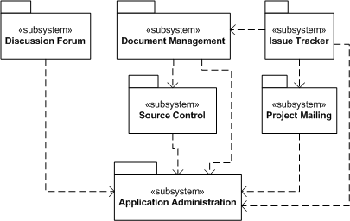
The Discussion Forum subsystem consists of all the interface, database and application domain components to permit project members to define discussion forums and converse within the forums.
The Document Management subsystem consists of all the interface, database and application domain components that permit project team members to check-in, check-out, version, create and delete documents within the project's repository.
The Issue Tracker subsystem consists of all the interface, database and application domain components for raising, tracking, closing and reporting on issues within a project. Issues may be associated with documents and rudimentary workflow functionality exists to apply actions to a document/issue which become linked and associated with other project personnel.
The Source Control subsystem consists of the low-level functionality for managing and versioning files within a file-system. This subsystem will more than likely be implemented by the Concurrent Versioning System (CVS).
The Project Mailing subsystem consists of the functionality for managing the workflow of documents and issues. This subsystem works similar to a listserv but is augmented with functionality for tracking and managing actions associated with document and issues. As document and issue actions are applied, this subsystem controls the email flow of the actions among project personnel.
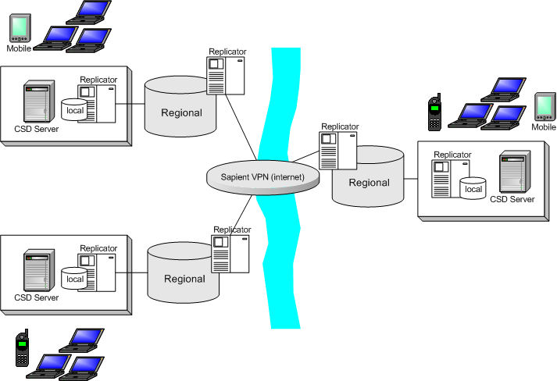
The Application Administration subsystem consists of the functionality for configuring and maintaining proper operations of the system.
The diagram to the right gives the location and network perspective on the CCT product.
This diagram illustrates the connectivity between local project repositories, and the regional, federated repositories. The physical combination of the local and regional repository (backups and caches) instances provide a single, logical repository for ABC Consulting project deliverables.
Via replication servers and regional file-systems & databases (physical repository), each project’s deliverables are made readily available to other projects within ABC Consulting. The diagram also illustrates the network and federation design that supports project collaboration across disparate locations such as between the United States and India.

Product position statement

ABC Consulting needs to centralise and better manage project artifacts. The CCT is a centralised web based collaboration tool that provides a centralised location for all project related artifacts

Summary of capabilities
ABC Consulting will gain the following general capabilities from the CCT:
- Global access to all product deliverables regardless of location.
- A standard tool base for managing deliverables will reduce costs and ease training of new personnel.
- Accessibility from a web browser. It simplifies administration and makes the solution more portable across a dynamic, widely-dispersed and mobile workforce.

Assumptions and dependencies
The following are the assumptions and dependencies for the CCT project:
- All project will have access to the Internet
- The Concurrent Versioning System (Subversion) will form the backbone of the repository.
- The primary interface to the application will be from an HTML-based web browser
- Applets and DHTML will be used to provide a rich client interface and provide the ability to update the file-system on the user's local computer.

Capabilities
Capability ID | Description
1 | Manages all forms of document whether they are PDF, MS Word, MS Project, Java source code, graphic files or text files regardless of format.
2 | Workflow and forum discussion exchange will permit improved coordination within and between projects as well as across continents.
3 | Easy to use administration tools allows project managers and project team managers to quickly configure new projects.
4 | Local project repositories are replicated to regional ABC Consulting servers. Promotes inter-project knowledge-exchange and a distributed workforce as well as centralized backup and recovery.
5 | The product will support and range of end-user devices including desktop web browsers, WAP phones and PDA web browsers.
6 | The network will be highly secure allowing private access from within or outside of ABC Consulting’s WAN/firewall.
7 | Common document management tools and infrastructure will reduce operational cost.
8 | Scalable solution permits rapid reconfiguration for new clients both within the United States and across the country.
9 | Designed using standards-based infrastructure resulting in a lower total cost of ownership (TCO).

Key Use Cases
Use Case | Role | Description
Document Management | Team Member | From an Internet web browser, a team member needs be able to manage documents within the repository.  The team member can check-in, check-out, view and modify documents. Each time a document is checked-in a new version of the document is created and when the team member checks out a document into his/her workspace, if the version number is not specified, the most current version is obtained.
Document Management | Team Member | A team member does not know the name of a particular document and requests a list of documents for his/her project. The system returns a list of documents and version numbers.
Document Management | Team Member | A team member needs to view an old version of a document. The team member enters a request to the system for the name of the document and the desired version and the system downloads the requested version into the team members workspace.
Document Management | Team Member | A team member just joined the project and has already been defined to the application. The team member wishes to create a workspace of their machine with the most current project deliverables. The team member logs into the application and requests that the entire project deliverables be checked out from the repository. The system complies and downloads each document into its corresponding folder on the team members machine. If the folder does not exist, the system creates the folder on the team member's machine.

Use Case | Role | Description
Issue Tracker | Project Manager | From an Internet web browser, the project manager can configure the issue tracking preferences and create groups.
Issue Tracker | Project Team Manager | The project team manager has full control over the issue tracking functionality. The project team manager can create, submit, delete, modify, reassign, search, print and fix issues. The project team manager can also print a variety of issue tracking reports as well as export the issues to an XML file.
Issue Tracker | Issue Creator` | The issue creator can use the application to open and submit issues. When an issue is submitted, the system returns a confirmation, an issue identifier and the time the issue was created.

Other product requirements

Applicable standards

- TCP/IP – Transmission Control Program
- HTTP – Hypertext Transfer Protocol
- SQL – Structured Query Language
- SMTP – Simple Mail Transfer Protocol
- J2SE – Java 2 Standard Edition
- J2EE – Java 2 Enterprise Edition

System requirements
- ABC Consulting personnel, once logged into the CCT application, must be able to access the deliverables from any active or completed project.
- All users must log into the application and in-turn authenticated against ABC Consulting’s internal domain. Once authenticated, the application will authorize access to various application functions based upon the user' role.
- The system must maintain access control lists (ACLs) for each user. A user's role and ACLs are associated with the user once they are authenticated.
- Documents must be replicated to a regional database within 15 minutes of being locally committed.
- Both HTML and WAP data streams must be eventually supported. HTML is the priority and must be implemented first.

Licensing, security, and installation
Describe any licensing, security, or installations, requirements that also affect the development effort or that create the need for separate installation software.

Performance requirements
Performance of the application is critical, and each page must be rendered in not more than 2 seconds.

